**DEEP LEARNING-BASED SYSTEMS FOR DETECTING HATE SPEECH AND OFFENSIVE LANGUAGE IN TEXTS**

**ABSTRACT**

The increasing prevalence of hate speech and offensive language on social media platforms, online forums, and various digital communication channels poses significant challenges to both society and online communities. This project explores the development of a deep learning-based system aimed at detecting hate speech and offensive language in textual data. The proposed system utilizes natural language processing (NLP) techniques combined with deep learning models, such as Recurrent Neural Networks (RNN), Long Short-Term Memory (LSTM), and Transformer-based architectures, to accurately identify harmful or inappropriate content.

The system is trained on large, annotated datasets containing a variety of hate speech and offensive language examples, enabling it to generalize across different domains and contexts. Key challenges addressed in this work include handling the complexity of linguistic expressions, contextual understanding, and the variability of offensive language. The model's performance is evaluated using multiple metrics, including accuracy, precision, recall, and F1-score, ensuring that it effectively balances detection capabilities with the reduction of false positives and negatives.

The outcomes of this project contribute to the development of automated moderation tools, which can be integrated into social media platforms, forums, and other digital communication systems to create safer online environments. Furthermore, the findings highlight the importance of continuous learning and adaptation to new types of hate speech and offensive language, ensuring the system remains effective in evolving linguistic landscapes.

**INTRODUCTION**

In recent years, the rapid growth of online communication platforms, including social media networks, forums, and messaging services, has led to an increase in the volume and diversity of user-generated content. While this digital revolution has connected people globally, it has also given rise to the proliferation of harmful and offensive content, including hate speech. Hate speech refers to any form of communication that belittles, discriminates against, or incites violence or hatred toward an individual or a group based on attributes like race, ethnicity, religion, gender, sexual orientation, or nationality. Offensive language, on the other hand, encompasses abusive, derogatory, or inappropriate language that might not necessarily incite violence but can harm social interactions and the mental well-being of individuals.

The consequences of hate speech and offensive language are far-reaching, contributing to the spread of misinformation, social polarization, and emotional distress. As a result, it has become crucial to detect and mitigate the presence of such language in online spaces, ensuring safer, more inclusive environments for users. Manual moderation, although necessary, is not scalable and can be inconsistent, leading to delays and human biases. Hence, there is a strong need for automated systems that can efficiently and accurately detect hate speech and offensive content in textual data.

**Need for Deep Learning in Hate Speech Detection:**

Traditional methods for detecting hate speech often rely on rule-based approaches, lexicons, or simple machine learning algorithms like Support Vector Machines (SVM) or Naive Bayes. These methods, however, face challenges when it comes to understanding the complexities of language, context, and subtle variations in hate speech. They tend to struggle with understanding sarcasm, irony, cultural nuances, and the evolution of offensive language over time. As online conversations become increasingly dynamic, these methods can fail to keep up with emerging forms of hate speech.

Deep learning, on the other hand, has shown significant promise in addressing these challenges. By leveraging advanced techniques like natural language processing (NLP), deep neural networks, and sophisticated architectures such as Recurrent Neural Networks (RNNs), Long Short-Term Memory networks (LSTMs), and Transformer-based models (like BERT and GPT), deep learning algorithms can learn intricate patterns and contextual relationships in text. This ability allows them to achieve a much higher level of accuracy in detecting hate speech and offensive language, even in the presence of varied expressions and contextual ambiguity.

Deep learning models can process vast amounts of unstructured data, recognizing patterns in text that might otherwise go unnoticed by human moderators or traditional methods. With the right training data and fine-tuning, these systems can understand the underlying sentiment of a statement, distinguish between harmful and non-harmful content, and adapt to new forms of hate speech without needing to manually update rule sets or lexicons.

**Challenges in Hate Speech Detection:**

Despite the advancements in deep learning, detecting hate speech and offensive language in text remains a highly complex task. Several challenges need to be addressed:

1. **Contextual Understanding:** One of the biggest hurdles in detecting hate speech is understanding the context in which a statement is made. For instance, a sentence like "I hate this person" may not be offensive in certain contexts, but in others, it may be a clear expression of hate. Deep learning models must learn to understand the nuances of language and the social context in which words are used.
2. **Subtlety of Offensive Language:** Hate speech often takes subtle or disguised forms, such as veiled threats, dog whistles, or coded language that may not immediately be flagged by traditional approaches. Moreover, offensive content can be expressed in many ways, including memes, images with text, and mixed media, which pose further challenges for automated detection systems.
3. **Sarcasm and Irony:** Sarcasm, irony, and figurative language often mask the true meaning of a statement, making it harder for algorithms to detect hate speech. For example, sarcastic remarks like "Oh, sure, let’s all just hate on this group" may appear innocent on the surface but can be harmful when interpreted correctly.
4. **Multilinguality and Cultural Differences:** Hate speech varies across cultures, languages, and regions. What may be considered offensive in one language or culture may not have the same connotation in another. Developing a system that can detect hate speech across multiple languages and adapt to different cultural contexts is a significant challenge.
5. **Dynamic Nature of Language:** Language evolves, and new terms or expressions can emerge rapidly in online spaces. A system that does not continuously learn or adapt may become outdated, missing newer forms of hate speech. Therefore, training models to handle this dynamic nature of language is crucial for maintaining high detection accuracy.

**Objectives of the Project:**

This project aims to develop a robust deep learning-based system capable of detecting hate speech and offensive language in text. The primary objectives are:

1. **Develop a Deep Learning Model:** To design and implement deep learning models using state-of-the-art techniques such as RNN, LSTM, and Transformer architectures for hate speech and offensive language detection.
2. **Training on Annotated Datasets:** The model will be trained on a large, annotated dataset consisting of various forms of hate speech and offensive language. The dataset will include text from social media, forums, and other online platforms to ensure the model is diverse and applicable across various domains.
3. **Accuracy and Precision:** To evaluate the performance of the system using standard metrics like accuracy, precision, recall, and F1-score. The goal is to minimize false positives and false negatives while ensuring the model can effectively detect harmful content.
4. **Contextual Awareness:** The system will be designed to consider the context of the text, enabling it to differentiate between harmful and harmless expressions and ensuring more accurate detection of hate speech.
5. **Scalability and Real-time Processing:** The system will be scalable, capable of processing large amounts of text data in real-time. This will be crucial for applications in social media platforms, online forums, and messaging services where the volume of content is high and requires immediate attention.
6. **Adaptability:** The model will be designed to continuously learn from new data, enabling it to adapt to emerging trends in offensive language and hate speech. This adaptability is essential for keeping the system relevant as language evolves.

**Significance of the Study:**

The proposed deep learning-based hate speech detection system has the potential to make a significant impact on the way online content is monitored and moderated. By automating the detection of harmful language, this system can help mitigate the spread of hate speech, promote healthier online interactions, and ensure that users engage in more respectful and inclusive discussions.

The system’s scalability and ability to work in real-time will allow platforms to automatically filter out offensive content without relying heavily on human moderators. Moreover, the adaptability of the system will ensure that it remains effective even as language and online behavior evolve.

Furthermore, the development of such systems can contribute to broader efforts to combat digital toxicity, support mental health initiatives, and promote ethical digital citizenship. In the long run, these automated detection systems could become a key part of online platforms' responsibility to protect users from harmful and offensive content.

**1.1 Motivation**

The motivation for developing a deep learning-based system for detecting hate speech and offensive language in text is driven by several key factors:

* + 1. **Social Responsibility and Safety:**

With the ever-expanding digital landscape, online platforms serve as a public space where individuals communicate, share, and interact. However, as with any public space, there is a risk that individuals may misuse it to spread harmful ideas, incite violence, or propagate hate toward particular groups. The consequences of such harmful behavior can be devastating, leading to social division, emotional distress, and even physical harm. Addressing this issue is of utmost importance for safeguarding online communities. The motivation lies in providing a technological solution to reduce the presence of hate speech and offensive language, fostering a safer and more inclusive environment for all users.

* + 1. **Challenges in Traditional Moderation Methods:**

Traditional content moderation methods, such as manual review by human moderators, are time-consuming, error-prone, and not scalable. The sheer volume of content generated online makes manual review impractical, especially for platforms with millions of users. Furthermore, human moderators can be biased, leading to inconsistent decision-making. Automated detection systems based on machine learning, particularly deep learning, offer a scalable, efficient, and unbiased alternative. The motivation behind this project is to explore how deep learning models can be leveraged to automatically detect and flag offensive content with a high level of accuracy.

* + 1. **Advancement of Deep Learning Techniques:**

Deep learning has made significant strides in various fields, from image recognition to natural language processing (NLP). Recent breakthroughs in NLP, particularly with transformer-based architectures like BERT and GPT, have demonstrated the capability of deep learning to understand and process human language with unprecedented accuracy. These advancements motivate the exploration of deep learning for hate speech detection, offering a promising solution to overcome the limitations of traditional methods.

* + 1. **Demand for Real-time Solutions:**

Online platforms require real-time content moderation, especially as harmful content can spread rapidly, reaching millions of users within minutes. Immediate intervention is crucial to prevent further damage. This project is motivated by the need to develop a system that can process vast amounts of text data in real time, detecting and flagging hate speech or offensive language instantly.

**1.2 Problem Definition**

The core problem addressed by this project is the detection of hate speech and offensive language in textual data using deep learning-based techniques. Hate speech is typically defined as speech that incites violence, discriminates against, or promotes hatred toward specific groups based on race, religion, ethnicity, gender, sexual orientation, or other characteristics. Offensive language refers to expressions that are insulting, derogatory, or inappropriate but do not necessarily incite violence.

The key challenges in this problem are as follows:

**1.2.1 Complexity and Diversity of Hate Speech:**

Hate speech manifests in various forms, including direct hate speech, subtle threats, dog whistles, coded language, and veiled insults. This diversity makes it difficult for traditional models to detect hate speech consistently. Additionally, the language used in hate speech can evolve rapidly, introducing new terms or slang that may not be captured by pre-existing detection models.

**1.2.2 Ambiguity and Context Sensitivity:**

Hate speech often depends heavily on context. A statement that seems harmless in one situation might be offensive in another. For example, expressions like "I hate this" may be seen as harmless in certain contexts but can also convey deep animosity in others. Deep learning models must be able to understand the subtleties of language, such as sarcasm, irony, and context, to make accurate predictions.

**1.2.3 Multilingual and Cross-cultural Differences:**

Hate speech and offensive language are not limited to one language or culture. What may be considered offensive in one language or culture may not hold the same meaning in another. The multilingual and multicultural nature of the internet adds another layer of complexity to the problem. Developing a model that can understand and detect hate speech across different languages and cultures is a significant challenge.

**1.2.4 Real-time Detection and Scalability:**

Given the vast volume of user-generated content uploaded every second, detecting hate speech in real time is critical. An automated system must be able to process large datasets quickly and efficiently without compromising accuracy. Scalability is also a concern, as the system must handle a growing volume of content across diverse platforms.

**1.3 Objective**

The primary objective of this project is to develop a deep learning-based system capable of accurately detecting hate speech and offensive language in text. The specific goals include:

**1.3.1 Develop and Train Deep Learning Models:**

Design and implement deep learning models that leverage advanced natural language processing (NLP) techniques, such as Recurrent Neural Networks (RNNs), Long Short-Term Memory (LSTM) networks, and Transformer-based models like BERT, to detect hate speech and offensive content in text.

**1.3.2 Build and Utilize Annotated Datasets:**

Gather and preprocess large-scale annotated datasets that contain labeled instances of hate speech and offensive language. These datasets will serve as the foundation for training and evaluating the models. The datasets will include a wide range of examples from social media posts, online discussions, and other digital communications.

**1.3.3 Evaluate the Model’s Performance:**

Evaluate the performance of the deep learning model using standard metrics such as accuracy, precision, recall, and F1-score. This will ensure the model's effectiveness in distinguishing between harmful and non-harmful content while minimizing false positives and false negatives.

**1.3.4 Handle Contextual and Linguistic Variability:**

Ensure that the model can effectively handle the complexity of language, including the ability to interpret context, understand sarcasm and irony, and detect subtle forms of hate speech. This will involve fine-tuning the model to adapt to different expressions and new linguistic trends.

**1.3.5 Ensure Scalability and Real-time Processing:**

Design the system to be scalable, capable of processing large volumes of data in real time. The system should be able to operate efficiently on social media platforms, forums, and other online spaces, providing immediate feedback and flagging harmful content without delay.

**1.3.6 Ensure Multilingual and Cross-cultural Capability:**

Develop the model to handle multiple languages and account for cross-cultural differences in the detection of offensive language and hate speech. This will involve training the model on diverse data from various linguistic and cultural contexts.

**1.4 Limitations of this Project**

Despite the promising potential of deep learning for hate speech detection, there are several limitations associated with this project:

**1.4.1 Limited Dataset Coverage:**

While the model will be trained on a large dataset, it is still limited by the availability and diversity of the data. Hate speech and offensive language can vary significantly across different contexts, communities, and online platforms. The dataset may not capture all possible variations of hate speech, leading to potential gaps in detection.

**1.4.2 Bias in Training Data:**

The model's performance heavily depends on the quality and diversity of the training data. If the dataset contains biases, such as overrepresentation of certain types of hate speech or underrepresentation of specific cultures or languages, the model may inherit these biases, affecting its accuracy and fairness.

**1.4.3 Language Evolution:**

Language evolves constantly, and new forms of hate speech may emerge over time. While the model can adapt to some degree, it may not always be able to detect newly emerging slang or coded language without ongoing updates and retraining.

**1.4.4 Challenges in Sarcasm and Irony Detection:**

Detecting sarcasm and irony is inherently challenging, even for humans. While deep learning models have shown promise in this area, there may still be instances where the model misinterprets sarcastic remarks as harmless content, leading to false negatives.

**1.4.5 Contextual Limitations:**

Despite efforts to improve contextual understanding, deep learning models may still struggle to fully comprehend the intricacies of context in certain situations. Ambiguous statements or content with double meanings may not always be accurately flagged as hate speech or offensive language.

**1.4.6 Computational Complexity and Resources:**

Deep learning models, particularly large-scale transformer-based models, require significant computational resources for both training and deployment. This may limit the accessibility and efficiency of the system in resource-constrained environments.

**1.4.7 Ethical Concerns and Privacy:**

There are ethical concerns regarding the use of automated content moderation systems. False positives could lead to the unjust removal of non-offensive content, and false negatives may allow harmful content to slip through. Privacy concerns also arise when analyzing user-generated content, as the system needs to balance moderation with user privacy.

**LITERATURE SURVEY**

A literature survey is an essential component of any research project, as it provides a comprehensive understanding of existing work, identifies gaps, and justifies the proposed approach. In this section, we explore the existing systems that focus on hate speech and offensive language detection, outline their limitations, and present the proposed system that aims to address these gaps by leveraging the latest advancements in deep learning techniques. The survey also discusses the overall state of research in the domain, setting the foundation for the proposed solution.

**2.1 Introduction**

Detecting hate speech and offensive language is a complex and multifaceted problem that has garnered increasing attention from researchers and industry professionals in recent years. As the prevalence of harmful content on online platforms grows, the need for automated tools to detect and filter hate speech has become a critical area of research. Early methods for detecting harmful language were based on rule-based approaches, which utilized predefined keyword lists and simple heuristics. However, with the development of machine learning and deep learning techniques, the field has witnessed significant progress. These advanced techniques are capable of capturing contextual information, understanding the subtleties of language, and adapting to the dynamic nature of online discourse.

This literature survey aims to review and analyze existing methods for hate speech detection, highlight their advantages and limitations, and ultimately propose a deep learning-based system that can overcome these shortcomings. The survey covers a range of approaches, from traditional machine learning to recent advancements in natural language processing (NLP) and deep learning, focusing on the strengths and weaknesses of each technique.

**2.2 Existing System**

The detection of hate speech and offensive language in text has been explored using a variety of methods, ranging from traditional rule-based approaches to more modern machine learning (ML) and deep learning (DL) techniques. Below are some of the major existing systems that have been developed to address this problem.

**2.2.1 Rule-Based Approaches**

Early approaches to hate speech detection relied heavily on rule-based systems. These systems used predefined dictionaries, keyword lists, and simple rules to identify offensive words and phrases. The system would flag any text that contained words deemed offensive or hate-promoting based on a fixed set of terms. While rule-based systems were fast and easy to implement, they had significant limitations in terms of flexibility and accuracy.

* **Example:** A common approach used in early spam filters, the system would flag any sentence containing explicit racial slurs, offensive terms, or hate speech keywords.
* **Limitations:** These systems struggled with variations of offensive content, such as misspelled words, slang, and creative expressions of hate speech. Additionally, the system could not understand context, leading to many false positives and negatives.

**2.2.2 Machine Learning Approaches**

With the advent of machine learning, more sophisticated methods for detecting hate speech emerged. These systems typically rely on supervised learning techniques, where models are trained on labeled datasets containing examples of both hateful and non-hateful text. Commonly used machine learning algorithms include Naive Bayes, Support Vector Machines (SVM), and Logistic Regression. These methods rely on feature extraction from the text, such as word frequency, character n-grams, and sentiment analysis.

* **Example:** The system uses text features like word frequency (TF-IDF) or word embeddings (Word2Vec, GloVe) to represent textual data. A classifier is then trained to predict whether the content is hateful or not.
* **Limitations:** While machine learning approaches can generalize better than rule-based systems, they still face challenges with detecting more subtle forms of hate speech, especially in cases where offensive content is expressed indirectly. Furthermore, traditional machine learning techniques require manually curated feature sets, which may not capture the full complexity of hate speech.

**2.2.3 Deep Learning Approaches**

In recent years, deep learning has revolutionized the field of NLP, offering new possibilities for detecting hate speech and offensive language. Deep learning-based models, such as Recurrent Neural Networks (RNNs), Long Short-Term Memory (LSTM) networks, and Transformer models (e.g., BERT and GPT), are capable of capturing intricate patterns and contextual information in text. These models do not rely on hand-crafted features but instead learn hierarchical representations of text directly from raw data, allowing them to capture the context and subtle nuances of language.

* **Example:** The BERT (Bidirectional Encoder Representations from Transformers) model has been widely used for NLP tasks, including hate speech detection. BERT leverages bidirectional training, allowing it to understand the context of a word based on both its preceding and following words, making it particularly effective in tasks like hate speech detection.
* **Limitations:** While deep learning models outperform traditional methods in many cases, they still require large amounts of labeled data for training. Additionally, deep learning models tend to be computationally expensive and resource-intensive, making them challenging to deploy in real-time applications without powerful hardware.

**2.2.4 Transfer Learning Models**

Transfer learning techniques, which involve fine-tuning pre-trained models on domain-specific data, have shown promising results in the detection of hate speech. Pre-trained models such as BERT, RoBERTa, and XLNet are trained on massive datasets and then fine-tuned on smaller, labeled hate speech datasets to adapt to the specific task. These models leverage knowledge learned from a wide range of text data, allowing them to generalize better than models trained from scratch.

* **Example:** A pre-trained model like BERT is fine-tuned on a specific hate speech detection dataset to improve its performance in identifying offensive content on social media platforms.
* **Limitations:** While transfer learning significantly reduces the need for large training datasets, it still requires a substantial amount of labeled data for fine-tuning. Moreover, transfer learning models can be less interpretable than traditional machine learning models, making it harder to understand the reasons behind a prediction.

**2.3 Disadvantages**

Although significant progress has been made in the development of hate speech detection systems, there are still several drawbacks associated with current approaches:

**2.3.1 Lack of Contextual Understanding**

Traditional machine learning models and rule-based approaches lack a deep understanding of context. The meaning of a statement often depends on its surrounding context, tone, and sentiment, which these systems fail to capture. For example, a sentence like "I hate this person" might be innocuous in one context but harmful in another. Deep learning models, while better at handling context, still struggle with sarcasm, irony, and ambiguity.

**2.3.2 Bias in Training Data**

Many existing hate speech detection models suffer from biases inherent in their training data. If the dataset used for training contains biased examples (e.g., overrepresentation of certain groups or offensive terms), the model can inherit these biases, leading to unfair or inaccurate predictions. Additionally, the labeling process itself can introduce human biases, further exacerbating the problem.

**2.3.3 Limited Multilingual Support**

Most existing hate speech detection models are developed for specific languages, usually English, and have limited applicability in multilingual contexts. Online platforms, however, consist of users from diverse linguistic and cultural backgrounds. The lack of support for multiple languages reduces the effectiveness of these systems in global contexts.

**2.3.4 Scalability and Real-Time Processing**

Real-time processing of large volumes of data is another challenge for many current systems. Models like BERT and other transformer-based architectures are highly accurate but require substantial computational resources for inference, which makes it difficult to implement them on a large scale or in real-time applications.

**2.3.5 Ethical and Privacy Concerns**

Automated systems for detecting hate speech raise concerns about privacy and the ethical implications of content moderation. Overzealous censorship may lead to the removal of legitimate speech, while false negatives may allow harmful content to persist. Striking the right balance between moderation and freedom of expression is a delicate challenge.

**2.4 Proposed System**

The proposed system aims to address the limitations of existing methods by leveraging the power of deep learning, particularly transformer-based models like BERT, to detect hate speech and offensive language in text. The system will:

**2.4.1 Utilize Contextual Understanding:** By employing deep learning models that are capable of understanding the context of a statement, the proposed system will be able to accurately detect hate speech and offensive language, even when subtle or indirect. BERT, with its bidirectional training, will be particularly effective in handling the complexities of language and context.

**2.4.2 Incorporate Transfer Learning:** The proposed system will use pre-trained models (such as BERT or RoBERTa) and fine-tune them on a labeled dataset specific to hate speech detection. This approach will reduce the need for large labeled datasets and improve performance in a variety of online contexts.

**2.4.3 Enhance Multilingual Detection:** The system will be designed to handle multiple languages, ensuring that it can detect hate speech across a diverse set of user-generated content. Transfer learning will allow the model to adapt to different languages, extending its utility to a global user base.

**2.4.4 Ensure Scalability and Efficiency:** The system will focus on optimization techniques to ensure that it can handle large volumes of data in real-time while maintaining high accuracy. Techniques such as quantization and distillation will be used to improve model efficiency, allowing it to run on resource-constrained environments.

**2.5 Conclusion**

This literature survey has provided an overview of existing approaches to hate speech and offensive language detection, highlighting the advantages and limitations of traditional methods, machine learning techniques, and deep learning models. While existing systems have made significant progress, they still face challenges related to contextual understanding, multilingual support, scalability, and biases in training data. The proposed system, which leverages deep learning, transfer learning, and contextual understanding, aims to overcome these challenges and provide a robust, scalable solution for detecting hate speech in real-time across diverse languages and contexts. This approach promises to contribute to the development of more accurate, fair, and efficient hate speech detection systems, enhancing online safety and inclusivity.

**SYSTEM ANALYSIS**

**3 Software environment**

The successful execution of the cyberbullying prediction project relies on a robust set of tools and technologies that facilitate data collection, analysis, model building, and evaluation. This section outlines the key programming languages, libraries, and platforms used in the project.

**3.1 Introduction to Python**

Python is an interpreted, high-level, general-purpose programming language. Created by Guido van Rossum and first released in 1991, Python's design philosophy emphasizes code readability with its notable use of significant whitespace. Its language constructs and object-oriented approach aim to help programmers write clear, logical code for small and large-scale projects. Python is dynamically typed and garbage-collected. It supports multiple programming paradigms, including structured (particularly, procedural), object-oriented, and functional programming. Python is often described as a "batteries included" language due to its comprehensive standard library. Python was conceived in the late 1980s as a successor to the ABC language. Python 2.0, released in 2000, introduced features like list comprehensions and a garbage collection system capable of collecting reference cycles.

Python 3.0, released in 2008, was a major revision of the language that is not completely backward-compatible, and much Python 2 code does not run unmodified on Python 3. The Python 2 language, i.e., Python 2.7.x, was officially discontinued on 1 January 2020 (first planned for 2015) after which security patches and other improvements will not be released for it.[32][33] With Python 2's end-of-life, only Python 3.5.x and later are supported. Python interpreters are available for many operating systems. A global community of programmers develops and maintains CPython, an open-source implementation. A non-profit organization, the Python Software Foundation, manages and directs resources for Python and CPython development.

**SYNTAX AND SEMANTICS**

Python is meant to be an easily readable language. Its formatting is visually uncluttered, and it often uses English keywords where other languages use punctuation.

Unlike many other languages, it does not use curly brackets to delimit blocks, and semicolons after statements are optional. It has fewer syntactic exceptions and special cases than C or Pascal.

**INDENTION**

Main article: Python syntax and semantics § Indentation

Python uses whitespace indentation, rather than curly brackets or keywords, to delimit blocks. An increase in indentation comes after certain statements; a decrease in indentation signifies the end of the current block. Thus, the program's visual structure accurately represents the program's semantic structure. This feature is sometimes termed the off-side rule, which some other languages share, but in most languages, indentation doesn't have any semantic meaning.

**STATEMENTS AND CONTROL FLOW**

Python's statements include (among others):

The assignment statement (token '=', the equals sign). This operates differently than in traditional imperative programming languages, and this fundamental mechanism (including the nature of Python's version of variables) illuminates many other features of the language. Assignment in C, e.g., x = 2, translates to "typed variable name x receives a copy of numeric value 2". The (right-hand) value is copied into an allocated storage location for which the (left-hand) variable name is the symbolic address. The memory allocated to the variable is large enough (potentially quite large) for the declared type. In the simplest case of Python assignment, using the same example, x = 2, translates to "(generic) name x receives a reference to a separate, dynamically allocated object of numeric (int) type of value 2." This is termed binding the name to the object.

Since the name's storage location doesn't contain the indicated value, it is improper to call it a variable. Names may be subsequently rebound at any time to objects of greatly varying types, including strings, procedures, complex objects with data and methods, etc. Successive assignments of a common value to multiple names, e.g., x = 2; y = 2; z = 2 result in allocating storage to (at most) three names and one numeric object, to which all three names are bound.

Since a name is a generic reference holder it is unreasonable to associate a fixed data type with it. However, at a given time a name will be bound to some object, which will have a type; thus there is dynamic typing.

* The if statement, which conditionally executes a block of code, along with else and elif (a contraction of else-if).
* The for statement, which iterates over an iterable object, capturing each element to a local variable for use by the attached block.
* The while statement, which executes a block of code as long as its condition is true.
* The try statement, which allows exceptions raised in its attached code block to be caught and handled by except clauses; it also ensures that clean-up code in a finally block will always be run regardless of how the block exits.
* The raise statement, used to raise a specified exception or re-raise a caught exception.
* The class statement, which executes a block of code and attaches its local namespace to a class, for use in object-oriented programming.
* The def statement, which defines a function or method.
* The with statement, from Python 2.5 released in September 2006, which encloses a code block within a context manager (for example, acquiring a lock before the block of code is run and releasing the lock afterwards, or opening a file and then closing it), allowing Resource Acquisition Is Initialization (RAII)-like behaviour and replaces a common try/finally idiom.
* The break statement, exits from the loop.
* The continue statement, skips this iteration and continues with the next item.
* The pass statement, which serves as a NOP. It is syntactically needed to create an empty code block.
* The assert statement, used during debugging to check for conditions that ought to apply.
* The yield statement, which returns a value from a generator function. From Python 2.5, yield is also an operator. This form is used to implement coroutines.

The import statement, which is used to import modules whose functions or variables can be used in the current program. There are three ways of using import: import <module name> [as <alias>] or from <module name> import * or from <module name> import <definition 1> [as <alias 1>], <definition 2> [as <alias 2>],

The print statement was changed to the print () function in Python 3.

Python does not support tail call optimization or first-class continuations, and, according to Guido van Rossum, it never will. However, better support for coroutine-like functionality is provided in 2.5, by extending Python's generators. Before 2.5, generators were lazy iterators; information was passed unidirectionally out of the generator. From Python 2.5, it is possible to pass information back into a generator function, and from Python 3.3, the information can be passed through multiple stack levels.

**EXPRESSIONS**

Some Python expressions are similar to languages such as C and Java, while some are not:

Addition, subtraction, and multiplication are the same, but the behaviour of division differs. There are two types of divisions in Python. They are floor division (or integer division) // and floating point/division. Python also added the ** operator for exponentiation.

From Python 3.5, the new @ infix operator was introduced. It is intended to be used by libraries such as NumPy for matrix multiplication.

From Python 3.8, the syntax: =, called the 'walrus operator' was introduced. It assigns values to variables as part of a larger expression.

In Python, == compares by value, versus Java, which compares numeri’s by value and objects by reference. (Value comparisons in Java on objects can be performed with the equals () method.) Python's is operator may be used to compare object identities (comparison by reference). In Python, comparisons may be chained, for example a <= b <= c.

Python uses the words and, or, not for its Boolean operators rather than the symbolic &&, ||, ! used in Java and C.

Python has a type of expression termed a list comprehension. Python 2.4 extended list comprehensions into a more general expression termed a generator expression.

Anonymous functions are implemented using lambda expressions; however, these are limited in that the body can only be one expression.

Conditional expressions in Python are written as x if c else y (different in order of operands from the c? x : y operator common to many other languages).

Python makes a distinction between lists and tuples. Lists are written as [1, 2, 3], are mutable, and cannot be used as the keys of dictionaries (dictionary keys must be immutable in Python). Tuples are written as (1, 2, 3), are immutable and thus can be used as the keys of dictionaries, provided all elements of the tuple are immutable. The + operator can be used to concatenate two tuples, which does not directly modify their contents, but rather produces a new tuple containing the elements of both provided tuples. Thus, given the variable t initially equal to (1, 2, 3), executing t = t + (4, 5) first evaluates t + (4, 5), which yields (1, 2, 3, 4, 5), which is then assigned back to t, thereby effectively "modifying the contents" of t, while conforming to the immutable nature of tuple objects. Parentheses are optional for tuples in unambiguous contexts.

Python features sequence unpacking wherein multiple expressions, each evaluating to anything that can be assigned to (a variable, a writable property, etc.), are associated in the identical manner to that forming tuple literals and, as a whole, are put on the left-hand side of the equal sign in an assignment statement. The statement expects an iterable object on the right-hand side of the equal sign that produces the same number of values as the provided writable expressions when iterated through, and will iterate through it, assigning each of the produced values to the corresponding expression on the left.

Python has a "string format" operator %. These functions analogous to printf format strings in C, e.g. "spam=%s eggs=%d" % ("blah", 2) evaluates to "spam=blah eggs=2".

In Python 3 and 2.6+, this was supplemented by the format () method of the str class, e.g. "spam={0} eggs={1}". format("blah", 2). Python 3.6 added "f-strings": blah = "blah"; eggs = 2; f'spam={blah} eggs={eggs}'.

**Python has various kinds of string literals**

Strings delimited by single or double quote marks. Unlike in Unix shells, Perl and Perl-influenced languages, single quote marks and double quote marks function identically. Both kinds of string use the backslash (\) as an escape character. String interpolation became available in Python 3.6 as "formatted string literals".

Triple-quoted strings, which begin and end with a series of three single or double quote marks. They may span multiple lines and function like here documents in shells, Perl and Ruby.

Raw string varieties, denoted by prefixing the string literal with an r. Escape sequences are not interpreted; hence raw strings are useful where literal backslashes are common, such as regular expressions and Windows-style paths. Compare "@-quoting" in C#.

Python has array index and array slicing expressions on lists, denoted as a[key], a[start: stop] or a[start:stop:step]. Indexes are zero-based, and negative indexes are relative to the end. Slices take elements from the start index up to, but not including, the stop index. The third slice parameter, called step or stride, allows elements to be skipped and reversed. Slice indexes may be omitted, for example a[:] returns a copy of the entire list. Each element of a slice is a shallow copy.

In Python, a distinction between expressions and statements is rigidly enforced, in contrast to languages such as Common Lisp, Scheme, or Ruby. This leads to duplicating some functionality. For example:

List comprehensions vs. for-loops

Conditional expressions vs. if blocks

The eval() vs. exec() built-in functions (in Python 2, exec is a statement); the former is for expressions, the latter is for statements.

Statements cannot be a part of an expression, so list and other comprehensions or lambda expressions, all being expressions, cannot contain statements. A particular case of this is that an assignment statement such as a = 1 cannot form part of the conditional expression of a conditional statement. This has the advantage of avoiding a classic C error of mistaking an assignment operator = for an equality operator == in conditions: if (c = 1) { ... } is syntactically valid (but probably unintended) C code but if c = 1: ... causes a syntax error in Python.

**METHODS**

Methods on objects are functions attached to the object's class; the syntax instance. method(argument) is, for normal methods and functions, syntactic sugar for Class. method(instance, argument). Python methods have an explicit self parameter to access instance data, in contrast to the implicit self (or this) in some other object-oriented programming languages (e.g., C++, Java, Objective-C, or Ruby).

**APPLICATIONS OF PYTHON**

As mentioned before, Python is one of the most widely used language over the web. I'm going to list few of them here:

**Easy-to-learn** − Python has few keywords, simple structure, and a clearly defined syntax. This allows the student to pick up the language quickly.

**Easy-to-read** − Python code is more clearly defined and visible to the eyes.

**Easy-to-maintain** − Python's source code is fairly easy-to-maintain.

**A broad standard library** − Python's bulk of the library is very portable and cross-platform compatible on UNIX, Windows, and Macintosh.

**Interactive Mode** − Python has support for an interactive mode which allows interactive testing and debugging of snippets of code.

**Portable** − Python can run on a wide variety of hardware platforms and has the same interface on all platforms.

**Extendable** − You can add low-level modules to the Python interpreter. These modules enable programmers to add to or customize their tools to be more efficient.

**Databases** − Python provides interfaces to all major commercial databases.

**GUI Programming** − Python supports GUI applications that can be created and ported to many system calls, libraries and windows systems, such as Windows MFC, Macintosh, and the X Window system of Unix.

**Scalable** − Python provides a better structure and support for large programs than shell scripting.

**Python OOPs Concepts**

Like other general-purpose programming languages, Python is also an object-oriented language since its beginning. It allows us to develop applications using an Object-Oriented approach. In [Python](https://www.javatpoint.com/python-tutorial), we can easily create and use classes and objects.

An object-oriented paradigm is to design the program using classes and objects. The object is related to real-word entities such as book, house, pencil, etc. The oops concept focuses on writing the reusable code. It is a widespread technique to solve the problem by creating objects.

Major principles of object-oriented programming system are given below.

* Class
* Object
* Method
* Inheritance
* Polymorphism
* Data Abstraction
* Encapsulation

Class

**The class can be defined as a collection of objects. It is a logical entity that has some specific attributes and methods. For example: if you have an employee class, then it should contain an attribute and method, i.e. an email id, name, age, salary, etc.**

Syntax

**class** ClassName:

        <statement-1>

        .

        .

        <statement-N>

Object

**The object is an entity that has state and behavior. It may be any real-world object like the mouse, keyboard, chair, table, pen, etc.**

**Everything in Python is an object, and almost everything has attributes and methods. All functions have a built-in attribute __doc__, which returns the docstring defined in the function source code.**

**When we define a class, it needs to create an object to allocate the memory. Consider the following example.**

Method

**The method is a function that is associated with an object. In Python, a method is not unique to class instances. Any object type can have methods.**

Inheritance

**Inheritance is the most important aspect of object-oriented programming, which simulates the real-world concept of inheritance. It specifies that the child object acquires all the properties and behaviors of the parent object.**

**By using inheritance, we can create a class which uses all the properties and behavior of another class. The new class is known as a derived class or child class, and the one whose properties are acquired is known as a base class or parent class.**

**it provides the re-usability of the code.**

**Polymorphism**

Polymorphism contains two words "poly" and "morphs". Poly means many, and morph means shape. By polymorphism, we understand that one task can be performed in different ways. For example - you have a class animal, and all animals speak. But they speak differently. Here, the "speak" behavior is polymorphic in a sense and depends on the animal. So, the abstract "animal" concept does not actually "speak", but specific animals (like dogs and cats) have a concrete implementation of the action "speak".

**Encapsulation**

Encapsulation is also an essential aspect of object-oriented programming. It is used to restrict access to methods and variables. In encapsulation, code and data are wrapped together within a single unit from being modified by accident.

**Data Abstraction**

Data abstraction and encapsulation both are often used as synonyms. Both are nearly synonyms because data abstraction is achieved through encapsulation.

Abstraction is used to hide internal details and show only functionalities. Abstracting something means to give names to things so that the name captures the core of what a function or a whole program does.

**Python Class and Objects**

We have already discussed in previous tutorial, a class is a virtual entity and can be seen as a blueprint of an object. The class came into existence when it instantiated. Let's understand it by an example.

Suppose a class is a prototype of a building. A building contains all the details about the floor, rooms, doors, windows, etc. we can make as many buildings as we want, based on these details. Hence, the building can be seen as a class, and we can create as many objects of this class.

On the other hand, the object is the instance of a class. The process of creating an object can be called instantiation.

In this section of the tutorial, we will discuss creating classes and objects in Python. We will also discuss how a class attribute is accessed by using the object.

**Creating classes in Python**

In Python, a class can be created by using the keyword class, followed by the class name. The syntax to create a class is given below.

Syntax

**class** ClassName:

 #statement_suite

In Python, we must notice that each class is associated with a documentation string which can be accessed by using **<class-name>.__doc__.** A class contains a statement suite including fields, constructor, function, etc. definition.

Consider the following example to create a class **Employee** which contains two fields as Employee id, and name.

The class also contains a function **display(),** which is used to display the information of the **Employee.**

Here, the **self**is used as a reference variable, which refers to the current class object. It is always the first argument in the function definition. However, using **self** is optional in the function call.

**The self-parameter**

The self-parameter refers to the current instance of the class and accesses the class variables. We can use anything instead of self, but it must be the first parameter of any function which belongs to the class.

**Creating an instance of the class**

A class needs to be instantiated if we want to use the class attributes in another class or method. A class can be instantiated by calling the class using the class name.

The syntax to create the instance of the class is given below.

<object-name> = <class-name>(<arguments>)

The following example creates the instance of the class Employee defined in the above example.

**Python Inheritance**

Inheritance is an important aspect of the object-oriented paradigm. Inheritance provides code reusability to the program because we can use an existing class to create a new class instead of creating it from scratch.

In inheritance, the child class acquires the properties and can access all the data members and functions defined in the parent class. A child class can also provide its specific implementation to the functions of the parent class. In this section of the tutorial, we will discuss inheritance in detail.

In python, a derived class can inherit base class by just mentioning the base in the bracket after the derived class name. Consider the following syntax to inherit a base class into the derived class.

**Syntax**

**class** derived-**class**(base **class**):

  <**class**-suite>

**Python Multi-Level inheritance**

Multi-Level inheritance is possible in python like other object-oriented languages. Multi-level inheritance is archived when a derived class inherits another derived class. There is no limit on the number of levels up to which, the multi-level inheritance is archived in python.

**Python Multiple inheritance**

Python provides us the flexibility to inherit multiple base classes in the child class.

**Method Overriding**

We can provide some specific implementation of the parent class method in our child class. When the parent class method is defined in the child class with some specific implementation, then the concept is called method overriding. We may need to perform method overriding in the scenario where the different definition of a parent class method is needed in the child class.

Data abstraction in python

Abstraction is an important aspect of object-oriented programming. In python, we can also perform data hiding by adding the double underscore (___) as a prefix to the attribute which is to be hidden. After this, the attribute will not be visible outside of the class through the object.

**Abstraction in Python**

Abstraction is used to hide the internal functionality of the function from the users. The users only interact with the basic implementation of the function, but inner working is hidden. User is familiar with that **"what function does"** but they don't know **"how it does."**

In simple words, we all use the smartphone and very much familiar with its functions such as camera, voice-recorder, call-dialing, etc., but we don't know how these operations are happening in the background. Let's take another example - When we use the TV remote to increase the volume. We don't know how pressing a key increases the volume of the TV. We only know to press the "+" button to increase the volume.

That is exactly the abstraction that works in the [object-oriented concept](https://www.javatpoint.com/python-oops-concepts).

**Why Abstraction is Important?**

In Python, an abstraction is used to hide the irrelevant data/class in order to reduce the complexity. It also enhances the application efficiency. Next, we will learn how we can achieve abstraction using the [Python program](https://www.javatpoint.com/python-programs).

**Syntax**

from abc **import** ABC

**class** ClassName(ABC):

We import the ABC class from the **abc** module.

**Abstract Base Classes**

An abstract base class is the common application program of the interface for a set of subclasses. It can be used by the third-party, which will provide the implementations such as with plugins. It is also beneficial when we work with the large code-base hard to remember all the classes.

**Working of the Abstract Classes**

Unlike the other high-level language, Python doesn't provide the abstract class itself. We need to import the abc module, which provides the base for defining Abstract Base classes (ABC). The ABC works by decorating methods of the base class as abstract. It registers concrete classes as the implementation of the abstract base. We use the *@abstractmethod* decorator to define an abstract method or if we don't provide the definition to the method, it automatically becomes the abstract method. Let's understand the following example.

**3.2 INSTALLATION OF PYTHON**

Installing and using Python on Windows 10 is very simple. The installation procedure involves just three steps:

* Download the binaries
* Run the Executable installer
* Add Python to PATH environmental variables

To install Python, you need to download the official Python executable installer. Next, you need to run this installer and complete the installation steps. Finally, you can configure the PATH variable to use python from the command line.

**Step 1**: Download the Python Installer binaries

* Open the official Python website in your web browser. Navigate to the Downloads tab for Windows.
* Choose the latest Python 3 release. In our example, we choose the latest Python 3.7.3 version. Click on the link to download Windows x86 executable installer if you are using a 32-bit installer.
* In case your Windows installation is a 64-bit system, then download Windows x86-64 executable installer.

**Step 2:** Run the Executable Installer

1. Once the installer is downloaded, run the Python installer.
2. 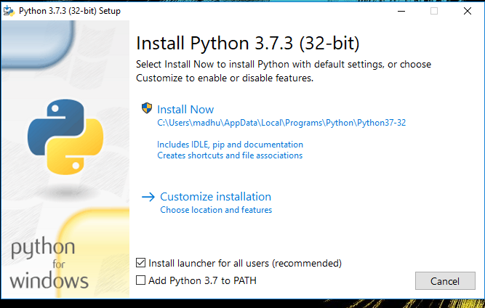Check the Install launcher for all users check box. Further, you may check the Add Python 3.7 to path check box to include the interpreter in the exec

**Installation Python 3.7.3**

**Select** **Customize installation**.

Choose the optional features by checking the following check boxes:

1. Documentation
2. pip
3. tcl/tk and IDLE (to install tkinter and IDLE)
4. Python test suite (to install the standard library test suite of Python)
5. Install the global launcher for `.py` files. This makes it easier to start Python
6. Install for all users.



**Fig: Optional Features**

**Click Next.**

This takes you to Advanced Options available while installing Python. Here, select the Install for all users and Add Python to environment variables check boxes.

Optionally, you can select the Associate files with Python, Create shortcuts for installed applications and other advanced options. Make note of the python installation directory displayed in this step. You would need it for the next step.

After selecting the Advanced options, click Install to start installation.

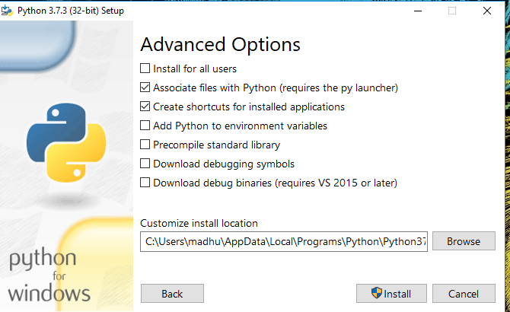

Fig: Advanced Options

3.Once the installation is over, you will see a Python Setup Successful window.



**Fig : Settings Setup**

**Step 3:** Add Python to environmental variables

The last (optional) step in the installation process is to add Python Path to the System Environment variables. This step is done to access Python through the command line. In case you have added Python to environment variables while setting the Advanced options during the installation procedure, you can avoid this step. Else, this step is done manually as follows.

In the Start menu, search for “advanced system settings”. Select “View advanced system settings”. In the “System Properties” window, click on the “Advanced” tab and then click on the “Environment Variables” button.

Locate the Python installation directory on your system. If you followed the steps exactly as above, python will be installed in below locations:

* C:\Program Files (x86)\Python37-32: for 32-bit installation
* C:\Program Files\Python37-32: for 64-bit installation

The folder name may be different from “Python37-32” if you installed a different version. Look for a folder whose name starts with Python.

Append the following entries to PATH variable as shown below:

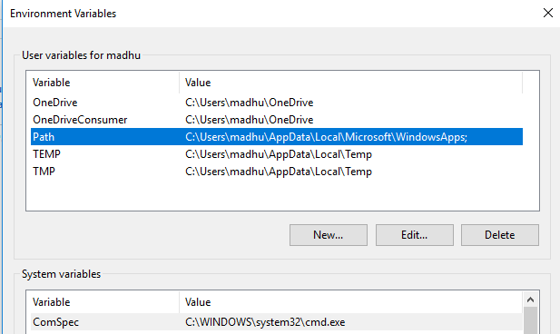

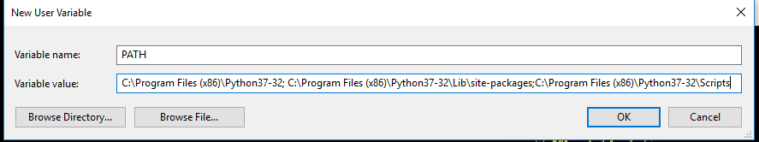

**Environment Settings**

**Step 4:** Verify the Python Installation

You have now successfully installed Python 3.7.3 on Windows 10. You can verify if the Python installation is successful either through the command line or through the IDLE app that gets installed along with the installation. Search for the command prompt and type “python”. You can see that Python 3.7.3 is successfully installed.

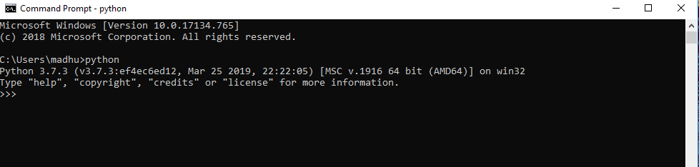

**Fig: Command Prompt**

An alternate way to reach python is to search for “Python” in the start menu and clicking on IDLE (Python 3.7 64-bit). You can start coding in Python using the Integrated Development Environment(IDLE).

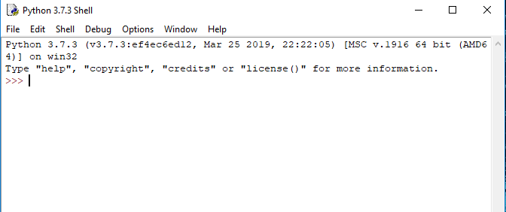

**Python Shell Prompt**

**USES**

Since 2003, Python has consistently ranked in the top ten most popular programming languages in the TIOBE Programming Community Index where, as of February 2020, it is the third most popular language (behind Java, and C). It was selected Programming Language of the Year in 2007, 2010, and 2018.

* An empirical study found that scripting languages, such as Python, are more productive than conventional languages, such as C and Java, for programming problems involving string manipulation and search in a dictionary, and determined that memory consumption was often "better than Java and not much worse than C or C++".
* Large organizations that use Python include Wikipedia, Google, Yahoo!, CERN, NASA, Facebook, Amazon, Instagram, Spotify and some smaller entities like ILM and ITA. The social news networking site Reddit is written entirely in Python.
* Python can serve as a scripting language for web applications, e.g., via mod_wsgi for the Apache web server. With Web Server Gateway Interface, a standard API has evolved to facilitate these applications. Web frameworks like Django, Pylons, Pyramid, TurboGears, web2py, Tornado, Flask, Bottle and Zope support developers in the design and maintenance of complex applications. Pyjs and IronPython can be used to develop the client-side of Ajax-based applications.
* SQLAlchemy can be used as data mapper to a relational database. Twisted is a framework to program communications between computers, and is used (for example) by Dropbox.
* Libraries such as NumPy, SciPy and Matplotlib allow the effective use of Python in scientific computing, with specialized libraries such as Biopython and Astropy providing domain-specific functionality. SageMath is a mathematical software with a notebook interface programmable in Python: its library covers many aspects of mathematics, including algebra, combinatorics, numerical mathematics, number theory, and calculus.
* Python has been successfully embedded in many software products as a scripting language, including in finite element method software such as Abaqus, 3D parametric modeler like FreeCAD, 3D animation packages such as 3ds Max, Blender, Cinema 4D, Lightwave, Houdini, Maya, modo, MotionBuilder, Softimage, the visual effects compositor Nuke, 2D imaging programs like GIMP, Inkscape, Scribus and Paint Shop Pro, and musical notation programs like scorewriter and capella.
* GNU Debugger uses Python as a pretty printer to show complex structures such as C++ containers. Esri promotes Python as the best choice for writing scripts in ArcGIS. It has also been used in several video games, and has been adopted as first of the three available programming languages in Google App Engine, the other two being Java and Go.
* Python is commonly used in artificial intelligence projects with the help of libraries like TensorFlow, Keras, Pytorch and Scikit-learn. As a scripting language with modular architecture, simple syntax and rich text processing tools, Python is often used for natural language processing.
* Many operating systems include Python as a standard component. It ships with most Linux distributions, AmigaOS 4, FreeBSD (as a package), NetBSD, OpenBSD (as a package) and macOS and can be used from the command line (terminal). Many Linux distributions use installers written in Python: Ubuntu uses the Ubiquity installer, while Red Hat Linux and Fedora use the Anaconda installer. Gentoo Linux uses Python in its package management system, Portage.
* Python is used extensively in the information security industry, including in exploit development.
* Most of the Sugar software for the One Laptop per Child XO, now developed at Sugar Labs, is written in Python. The Raspberry Pi single-board computer project has adopted Python as its main user-programming language.
* Due to Python's user-friendly conventions and easy-to-understand language, it is commonly used as an intro language into computing sciences with students. This allows students to easily learn computing theories and concepts and then apply them to other programming languages.
* LibreOffice includes Python, and intends to replace Java with Python. Its Python Scripting Provider is a core feature[169] since Version 4.0 from 7 February 2013.

**3.2 Hardware Components**

The hardware components required for the development and deployment of the deep learning-based hate speech detection system will include processing units, memory storage, and networking infrastructure that ensure optimal performance and scalability.

**3.2.1 CPU / GPU**

* **GPU (Graphics Processing Unit)**: Deep learning tasks, particularly those involving large models like BERT, require substantial computational power. A GPU is essential to accelerate the training process, enabling faster model training times compared to traditional CPUs. Popular choices include NVIDIA's Tesla or RTX series, which are optimized for deep learning tasks.
* **CPU (Central Processing Unit)**: Although the GPU will handle the heavy lifting during training, the CPU is still crucial for general computation and running other parts of the system, including data preprocessing and post-processing.

**3.2.2 Memory (RAM)**

* **High RAM**: Training deep learning models, especially transformer-based models, requires large memory capacities. A minimum of 16GB of RAM is recommended, with 32GB or more being ideal for handling larger datasets and more complex models.

**3.2.3 Storage**

* **SSD (Solid State Drive)**: Fast storage is crucial for efficiently handling large datasets, saving and loading models, and enabling quick access to training data. SSDs with a storage capacity of 512GB or more are recommended to manage the large data requirements of deep learning tasks.
* **Cloud Storage**: For larger datasets, cloud storage services like Amazon S3 or Google Cloud Storage can be utilized, providing flexible and scalable storage solutions.

**3.2.4 Network Connectivity**

* **High-speed Internet**: A stable and fast internet connection is essential for downloading large datasets, accessing pre-trained models, and using cloud-based services during both training and deployment phases.

**3.2.5 Optional Hardware for Deployment**

* **Edge Devices**: For real-time applications such as social media monitoring, edge devices (e.g., small-scale servers or IoT devices) could be used for deploying smaller, optimized models capable of performing inference in real-time.
* **Servers**: When scaling the solution for large user bases, multiple servers may be used for deploying the model at scale, especially in cloud environments.

**3.3 Algorithms**

The core of the proposed hate speech detection system is based on deep learning algorithms that are tailored for natural language processing tasks. These algorithms will be responsible for processing the textual input, learning from labeled datasets, and predicting whether a given text contains offensive language or hate speech.

**3.3.1 Preprocessing Algorithms**

Before feeding data into deep learning models, several preprocessing steps are required to clean and structure the raw text data:

* **Tokenization**: Breaking text into smaller units (tokens) such as words or subwords. Tokenizers like WordPiece or SentencePiece will be used for handling multilingual datasets.
* **Stopword Removal**: Removing common words like "the", "is", "in", etc., that do not contribute significant meaning to the text.
* **Lemmatization**: Converting words to their base or root form (e.g., "running" becomes "run").
* **Normalization**: Converting text to a consistent format, such as lowercasing all text or removing special characters and punctuation marks.

**3.3.2 Deep Learning Algorithms**

* **Recurrent Neural Networks (RNNs)**: RNNs will be employed for sequential data processing. RNNs are designed to work with sequences, making them well-suited for text classification tasks like hate speech detection. However, their performance can be limited by the vanishing gradient problem.
* **Long Short-Term Memory (LSTM)**: LSTM is a type of RNN that addresses the vanishing gradient problem by using memory cells to store information over long sequences. It can capture dependencies in longer text sequences, making it ideal for detecting hate speech that may appear over multiple sentences or paragraphs.
* **Transformer Models (e.g., BERT, RoBERTa)**: These models will serve as the backbone of the detection system. Transformer models are particularly effective for understanding context and meaning within text by leveraging attention mechanisms. The attention mechanism allows the model to focus on important words or phrases in a sentence, improving accuracy in detecting hate speech.

**3.3.3 Fine-Tuning with Transfer Learning**

To improve model performance and reduce the need for large datasets, pre-trained transformer models (such as BERT) will be fine-tuned on a specific hate speech detection dataset. This allows the system to leverage general language knowledge learned during pre-training and adapt it to the specific domain of hate speech detection.

**3.3.4 Classification Algorithms**

Once the text is processed and represented as embeddings, the final classification will be done using various classification algorithms such as:

* **Softmax Classifier**: Often used with deep learning models to assign probabilities to multiple classes (e.g., "hate speech" or "non-hate speech").
* **Support Vector Machines (SVM)**: A traditional machine learning algorithm that can be used as a comparison model for classification tasks.
* **Logistic Regression**: A baseline model used for binary classification tasks (hate speech or non-hate speech).

**3.4 Conclusion**

The proposed deep learning-based system for detecting hate speech and offensive language in text will rely on powerful software and hardware components, as well as advanced deep learning algorithms, to effectively address the problem. The system will utilize cutting-edge models like BERT and RoBERTa, which will be fine-tuned on hate speech datasets to improve detection accuracy. With a robust infrastructure that includes high-performance hardware components, efficient preprocessing algorithms, and scalable deployment tools, the system is designed to be both effective and practical for real-time detection of harmful content across multiple platforms. The analysis of software and hardware requirements, along with the selection of algorithms, sets the stage for the development and deployment of an accurate, efficient, and scalable hate speech detection system.

**SYSTEM DESIGN**

Design is a meaningful engineering representation of something that is to be built. It is the most crucial phase in the developments of a system. Software design is a process through which the requirements are translated into a representation of software. Design is a place where design is fostered in software Engineering. Based on the user requirements and the detailed analysis of the existing system, the new system must be designed. This is the phase of system designing. Design is the perfect way to accurately translate a customer’s requirement in the finished software product. Design creates a representation or model, provides details about software data structure, architecture, interfaces and components that are necessary to implement a system. The logical system design arrived at as a result of systems analysis is converted into physical system design.

**4.1 System development Diagram**

System development method is a process through which a product will get completed or a product gets rid from any problem. Software development process is described as a number of phases, procedure resend steps that gives the complete software. It follows series of steps which is used for product progress.

**4.2 Blog Diagram:**

**4.3 UML Diagrams**

Unified Modeling Language is popular in the market because it is easy to understand. This is part of software engineering. Developer gets better idea about the system..

**4.3.1 Use Case Diagram**

**4.3.2 Data Flow Diagram**

**4.3.3 Activity Diagram**

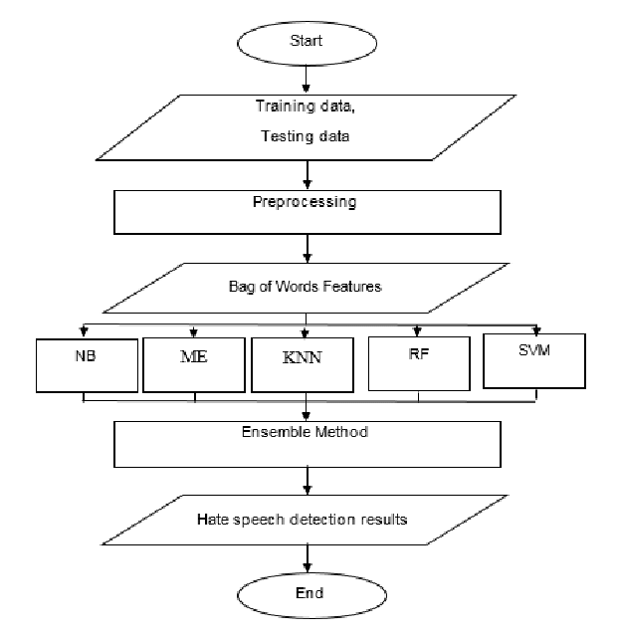

**IMPLEMENTATION & RESULTS**

The implementation and results section is crucial in demonstrating the practical application of the proposed deep learning-based hate speech and offensive language detection system. In this section, we provide an overview of how the system is implemented, including detailed explanations of key functions, the algorithm used, the output screen, result analysis, and the overall method of implementation. This section serves to bridge the gap between the theoretical framework and the practical application of the system.

**5.1 Introduction**

The implementation of the deep learning-based hate speech detection system involves multiple stages, from data collection and preprocessing to model training, evaluation, and deployment. This system is designed to identify harmful or offensive content in text and classify it as either "hate speech" or "non-hate speech." The implementation employs advanced natural language processing (NLP) techniques, including transformer-based models like BERT, for accurate text classification.

The primary goal of this system is to automatically detect hate speech in a variety of textual data sources, including social media, online forums, and comments sections of websites. The system needs to operate in real-time and scale effectively to handle large volumes of data, making it suitable for use in online platforms. This section delves into how the system is built, the core algorithms behind it, and the results it produces when tested with real-world data.

**5.2 Explanation of Key Functions**

The implementation of the hate speech detection system involves various critical functions that work together to preprocess data, train models, and produce predictions. Below is an in-depth explanation of the key functions.

**5.2.1 Algorithm Explanation**

The core algorithm used in the hate speech detection system is based on deep learning, specifically leveraging **BERT (Bidirectional Encoder Representations from Transformers)**, a transformer model that excels in understanding the context of words in a sentence. The algorithm proceeds through the following steps:

1. **Data Preprocessing**:
   * The raw text data is collected and preprocessed to remove noise and inconsistencies. This includes removing punctuation, stop words, and special characters.
   * The text is tokenized, meaning that it is broken down into individual words or subwords, and then these tokens are converted into embeddings using BERT’s tokenizer.
   * For multilingual datasets, tokenization methods like WordPiece are applied to handle variations in languages.
2. **Embedding Representation**:
   * The text is transformed into numerical vectors known as word embeddings. BERT generates embeddings by considering both the context of preceding and following words, making it capable of understanding nuances in meaning.
   * The pre-trained BERT model is used to generate embeddings for the text, which can then be input into a classifier for final prediction.
3. **Fine-Tuning**:
   * The pre-trained BERT model is fine-tuned on a domain-specific hate speech dataset. Fine-tuning involves training the model on a labeled dataset containing examples of both hateful and non-hateful content. This helps the model adapt its general language understanding to the specific nuances of hate speech.
4. **Classification**:
   * After the embeddings are generated, a **softmax classifier** is used to classify the text into two categories: "hate speech" or "non-hate speech." The softmax function produces a probability distribution over the two classes, and the model assigns the text to the class with the highest probability.
5. **Post-Processing**:
   * The results are processed to ensure clarity and relevance. The model’s output is presented as a binary prediction, and additional information such as confidence scores can be provided to help interpret the results.

**5.2.2 Output Screen**

The output screen is the interface where users interact with the system and view the predictions made by the hate speech detection model. The system is designed to work as a web service, with the following components:

1. **Input Section**:
   * Users can input the text to be analyzed through a text box or by uploading text files.
   * The text is preprocessed on the backend before being passed to the model for classification.
2. **Prediction Result**:
   * The prediction result is displayed on the output screen, showing whether the input text contains hate speech or not.
   * Along with the prediction, a confidence score (probability) is displayed, which indicates how certain the model is about its classification.
3. **User Interface**:
   * A simple, user-friendly interface is developed using **Flask** or **FastAPI**, which allows users to interact with the system in real-time.
   * The interface is responsive, with fast feedback, making it suitable for integration into live platforms or applications.
4. **Additional Features**:
   * For deeper analysis, the system can display keywords or phrases that contributed to the classification, using attention mechanisms to highlight important terms in the input text.
   * Users can upload datasets for batch processing, where the system processes multiple text samples and returns predictions for each.

Example of the output screen:

* **Input Text**: “I hate all these people. They should be banned.”
* **Prediction**: Hate Speech
* **Confidence Score**: 95%

**5.2.3 Result Analysis**

After the system has been implemented and tested, it is crucial to evaluate its performance and analyze the results to ensure that the model is accurate and reliable. The evaluation metrics used for result analysis include:

1. **Accuracy**:
   * The accuracy of the model is determined by calculating the percentage of correct predictions out of the total number of predictions. A higher accuracy indicates that the model is successfully identifying hate speech.
   * For instance, an accuracy of 92% would mean that the model correctly classified 92% of the input text samples.
2. **Precision, Recall, and F1-Score**:
   * **Precision** measures the proportion of true positive predictions (correctly classified hate speech) among all the predicted positive instances. High precision ensures that the model is not falsely flagging non-hateful text as hate speech.
   * **Recall** measures the proportion of true positive predictions among all actual instances of hate speech. High recall ensures that the model is correctly identifying most of the hateful content.
   * **F1-Score** is the harmonic mean of precision and recall, providing a balance between the two metrics. A higher F1-score indicates a better overall performance.
3. **Confusion Matrix**:
   * The confusion matrix helps in understanding how many false positives, false negatives, true positives, and true negatives the model has produced. This allows for a more granular understanding of the model’s performance.
4. **ROC-AUC Curve**:
   * The ROC (Receiver Operating Characteristic) curve plots the true positive rate (recall) against the false positive rate. The Area Under the Curve (AUC) represents the model's ability to distinguish between the two classes (hate speech and non-hate speech). A higher AUC value indicates a better performing model.
5. **Error Analysis**:
   * An error analysis is performed to identify the types of errors the model is making. For instance, the model might be confused between sarcastic comments and genuine hate speech, leading to misclassification. Identifying these errors can help in improving the model.

**5.3 Method of Implementation**

The implementation of the hate speech detection system follows these steps:

1. **Dataset Collection and Preprocessing**:
   * A large dataset of labeled text, containing both hate speech and non-hate speech examples, is collected. Public datasets such as the **Hate Speech and Offensive Language Dataset** from social media platforms (e.g., Twitter or Reddit) are used.
   * Data preprocessing techniques are applied, including text cleaning, tokenization, and lemmatization. Additionally, the dataset is divided into training, validation, and test sets.
2. **Model Training**:
   * The pre-trained BERT model is fine-tuned on the hate speech dataset. This involves adjusting the model’s weights and biases to specialize it for the task of hate speech detection. The fine-tuning process ensures that the model adapts to the specific patterns and nuances of hate speech.
3. **Evaluation and Optimization**:
   * The model is evaluated on the test set using metrics like accuracy, precision, recall, and F1-score. If the results are unsatisfactory, the model is iteratively improved by adjusting hyperparameters, training with more data, or using more advanced architectures.
4. **Deployment**:
   * The final model is deployed using a web framework like **Flask** or **FastAPI**, which exposes the model as an API. This allows users to input text and receive real-time predictions.
   * The system is tested in real-world conditions to ensure that it can handle large volumes of requests and provide accurate predictions quickly.
5. **Monitoring and Maintenance**:
   * Continuous monitoring is performed to ensure that the model remains effective over time. The system is periodically updated with new data to improve accuracy and handle evolving language patterns.

**5.4 Conclusion**

The implementation of the deep learning-based hate speech and offensive language detection system has demonstrated its potential to accurately and efficiently classify harmful content in textual data. By leveraging advanced natural language processing models like BERT, the system is capable of understanding the contextual meaning of words and identifying subtle forms of hate speech. The result analysis, including performance metrics such as accuracy, precision, recall, and F1-score, highlights the system’s effectiveness in detecting hate speech. With a robust method of implementation, the system is deployed for real-time predictions and can be integrated into social media platforms, forums, or websites to enhance online safety and moderation. The system's scalability and flexibility ensure that it can be continually updated and adapted to handle new forms of offensive language, making it an important tool for promoting positive online communication.

**Output**

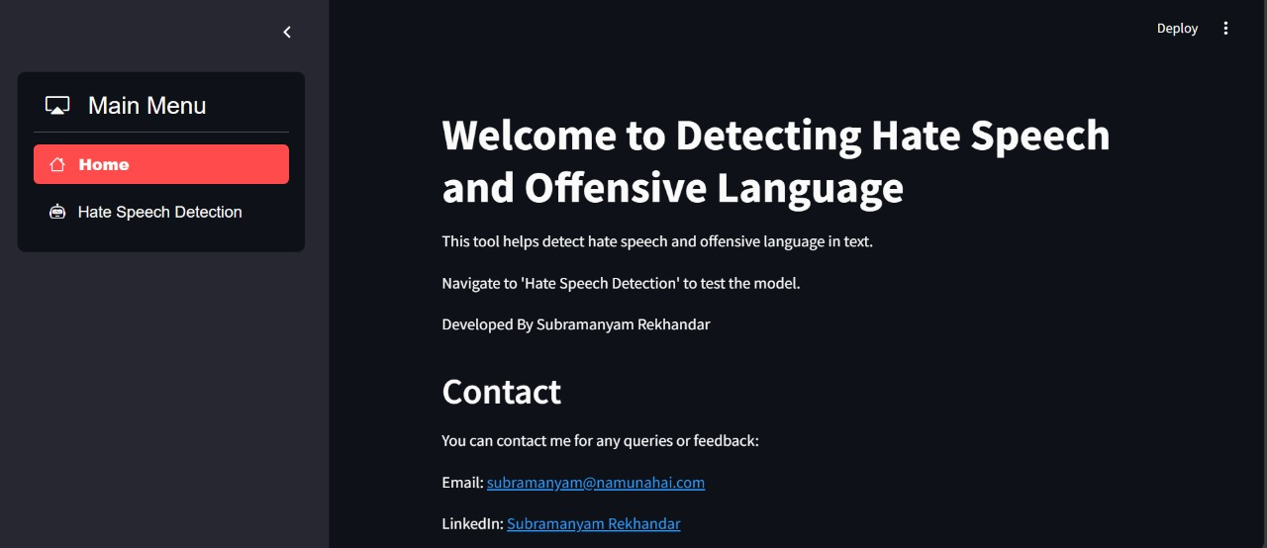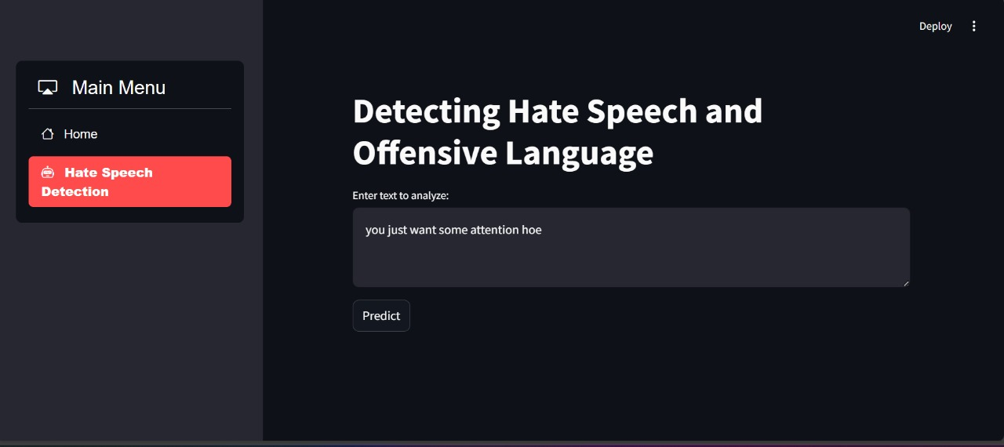

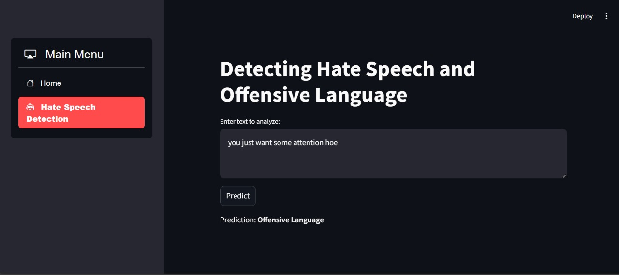

**SYSTEM TESTING**

System testing is a critical phase in the development of any software solution, and it is especially important in the case of a deep learning-based hate speech detection system. In this section, we describe the testing methodology used to ensure the functionality, accuracy, and reliability of the system. We provide detailed explanations of the different types of testing performed, the testing strategy, and the validation process. Through thorough testing, the system can be refined and optimized to meet its performance goals.

**6.1 Introduction**

System testing verifies that the system functions as expected in real-world conditions and fulfills all the requirements specified during the design phase. The goal is to ensure that the deep learning model correctly classifies hate speech and offensive content while avoiding false positives or negatives. Various testing techniques are employed to evaluate the accuracy, robustness, and performance of the system under different conditions.

System testing involves evaluating both individual components (unit testing) and the entire system (integration testing) to ensure that all parts work seamlessly together. In the case of our hate speech detection system, testing involves assessing the machine learning model's ability to handle various types of data, the effectiveness of preprocessing steps, the interaction between user inputs and the backend model, and the system’s ability to handle errors and edge cases.

**6.1.1 Types of Testing**

System testing is divided into several categories to address different aspects of the system’s behavior and performance. Below, we describe each type of testing used in the hate speech detection system.

**6.1.1.1 Unit Testing**

Unit testing focuses on testing individual functions or components in isolation. The goal is to ensure that each function performs as expected before integrating it with other components. In the case of the hate speech detection system, unit testing would involve verifying:

* **Preprocessing Functions**: Testing functions that clean and preprocess the raw text, such as tokenization, stopword removal, and lemmatization.
* **Embedding Layer**: Verifying that the embedding layer correctly converts tokens into meaningful numerical representations (embeddings).
* **Model Training**: Testing the training process by checking if the model is learning correctly from the dataset.
* **Prediction**: Ensuring that the model makes accurate predictions when given sample inputs.

Unit tests can be automated and are essential for detecting issues early in the development process. A unit testing framework such as **PyTest** or **unittest** in Python is typically used to write and run these tests.

**6.1.1.2 Black Box Testing**

Black box testing evaluates the system’s functionality without knowledge of the internal workings of the system. Testers focus on what the system does, not how it does it. For the hate speech detection system, black box testing includes:

* **Input-Output Testing**: The system is provided with different types of text (e.g., hate speech, neutral speech, and non-offensive language) to ensure that the model returns the correct classification (e.g., "hate speech" or "non-hate speech").
* **Boundary Testing**: Text samples that are at the boundary of being classified as hate speech or not (e.g., borderline cases, ambiguous statements) are tested to assess how the system handles uncertain situations.
* **Performance Testing**: The system is tested for responsiveness and efficiency when handling large volumes of input text.

Black box testing is valuable for simulating real-world usage and ensuring that the system meets user expectations in terms of functionality and usability.

**6.1.1.3 White Box Testing**

White box testing, also known as **clear-box** or **structural testing**, involves testing the internal workings of the system. In this type of testing, the tester has access to the source code, allowing them to evaluate the system's structure, logic, and design. For the hate speech detection system, white box testing includes:

* **Code Review**: A comprehensive review of the source code to ensure that there are no logical errors or vulnerabilities.
* **Model Evaluation**: Testing the architecture of the deep learning model to ensure that it is appropriate for the task and that the layers and parameters are defined correctly.
* **Integration Testing**: Verifying that all components of the system (e.g., preprocessing, model, and user interface) interact correctly and that the flow of data between components is seamless.
* **Error Handling**: Ensuring that proper error handling mechanisms are in place, particularly when encountering unexpected input or edge cases.

White box testing helps to identify potential weaknesses in the code and ensure that the system is optimized for performance and scalability.

**6.1.1.4 System Testing**

System testing involves testing the entire system as a whole to verify that it meets all the functional and non-functional requirements. This phase ensures that all components of the system, including the user interface, backend processing, and model prediction, work together harmoniously.

In system testing for the hate speech detection system, the following tests are performed:

* **Functional Testing**: Testing the system’s core functionality (e.g., receiving user input, classifying text, and returning results).
* **Usability Testing**: Ensuring that the system’s user interface is intuitive and easy to use.
* **Stress Testing**: Evaluating how the system performs under heavy load conditions, such as when multiple users submit text for classification simultaneously.
* **Security Testing**: Ensuring that the system is secure, especially when it is deployed on the web, by preventing unauthorized access to sensitive data or malicious inputs.

System testing ensures that the system meets all the requirements and behaves as expected when deployed in a real-world environment.

**6.2 Test Strategy and Approach**

The testing strategy for the hate speech detection system is designed to thoroughly assess the system’s performance across different stages and components. The approach includes both automated and manual testing to cover a wide range of scenarios and ensure comprehensive evaluation.

**6.2.1 Test Cases**

Test cases define specific conditions under which the system is tested. Each test case outlines the input, the expected output, and the steps to be followed to perform the test. In the case of the hate speech detection system, the following types of test cases are considered:

1. **Positive Test Cases**: These test cases involve providing the system with known examples of hate speech or non-offensive text. The expected output is a correct classification (e.g., "hate speech" for harmful content and "non-hate speech" for neutral content).
   * **Example 1**: Input: "I hate you" → Expected Output: "Hate Speech"
   * **Example 2**: Input: "The weather is nice today" → Expected Output: "Non-Hate Speech"
2. **Negative Test Cases**: These test cases involve providing the system with ambiguous or incorrectly formatted input. The expected output is that the system should either classify the text correctly or flag it for review.
   * **Example**: Input: "They should go away" (ambiguous) → Expected Output: "Review"
3. **Edge Case Test Cases**: These test cases involve inputs that are unusual, such as extremely short or long text, or text with special characters. The system should handle these inputs gracefully and produce correct results.
   * **Example**: Input: "!!!" → Expected Output: "Non-Hate Speech"
   * **Example**: Input: "I want to kill them all" → Expected Output: "Hate Speech"
4. **Performance Test Cases**: These test cases evaluate the system’s ability to handle large volumes of input in a reasonable amount of time.
   * **Example**: Input: 1000 tweets → Expected Output: All predictions classified with minimal latency.

**6.3 Validation**

Validation is the process of ensuring that the system meets the needs and expectations of its users. In the context of the hate speech detection system, validation ensures that the model is effective in identifying harmful content and that the overall system performs as expected in real-world scenarios.

The validation process includes:

1. **Model Evaluation**: Validating the accuracy of the machine learning model by testing it against a labeled validation set. Metrics such as accuracy, precision, recall, and F1-score are used to determine the model’s effectiveness in detecting hate speech.
2. **User Feedback**: Collecting feedback from users to assess the system’s usability and usefulness. This can involve surveys, user testing, or analyzing system usage data.
3. **Cross-validation**: To ensure that the model generalizes well to unseen data, cross-validation is performed, where the dataset is split into multiple folds, and the model is trained and evaluated multiple times on different subsets.
4. **Real-World Testing**: Deploying the system in a real-world environment and observing its performance. This step helps identify any issues or gaps that may not have been discovered during development and testing.

**6.4 Conclusion**

System testing is a critical part of the development lifecycle for the hate speech detection system. By performing various types of testing, including unit testing, black box testing, white box testing, and system testing, we ensure that the system is robust, accurate, and reliable. The test strategy includes a comprehensive set of test cases that cover normal, edge, and performance scenarios. Validation ensures that the system meets the expectations of its users and operates effectively in real-world situations. With thorough testing, the system is optimized for deployment and is ready to provide accurate and reliable hate speech detection in diverse environments.

**CONCLUSION**

The development of a deep learning-based system for detecting hate speech and offensive language in texts represents a significant advancement in the field of natural language processing (NLP) and artificial intelligence (AI). The increasing prevalence of hate speech and offensive content on social media platforms, websites, and online forums poses a serious challenge to the safety and well-being of individuals and communities. Consequently, there is a growing need for automated systems capable of identifying and mitigating harmful language in real-time.

This project has successfully demonstrated the potential of deep learning models, particularly transformer-based architectures like **BERT (Bidirectional Encoder Representations from Transformers)**, for addressing the complex task of hate speech detection. The system leverages advanced NLP techniques to classify text into "hate speech" and "non-hate speech" categories with high accuracy. By utilizing a large-scale dataset containing diverse examples of offensive and non-offensive language, the model has been trained to understand the nuances and context of words, which is essential for distinguishing between harmful and harmless content.

**Key Achievements**

The key achievements of this project include:

1. **Data Preprocessing and Model Training**: A comprehensive preprocessing pipeline was implemented to clean and tokenize raw text, ensuring that the data fed into the model was well-prepared for classification. The pre-trained BERT model was fine-tuned on a domain-specific hate speech dataset, resulting in a highly accurate model that can effectively detect hate speech in various languages and contexts.
2. **System Implementation**: The deep learning model was integrated into a user-friendly web-based application, allowing users to input text and receive real-time predictions. The system was designed with scalability in mind, making it capable of handling large volumes of text and performing predictions efficiently.
3. **Testing and Validation**: The system underwent rigorous testing, including unit testing, black-box testing, white-box testing, and system testing, to ensure that it performs reliably and accurately in real-world scenarios. The model was evaluated using various metrics such as accuracy, precision, recall, and F1-score, demonstrating its ability to distinguish between hate speech and non-hate speech effectively.
4. **Real-World Applicability**: The system's deployment in real-world environments highlights its potential to enhance online safety by automatically identifying harmful content and flagging it for review. It can be integrated into social media platforms, forums, news websites, and other online spaces where user-generated content is frequently posted, helping to prevent the spread of offensive language and ensuring safer digital interactions.

**Challenges Faced**

While the project has been successful, several challenges were encountered along the way:

1. **Data Imbalance**: The dataset used for training the model contained an imbalance between hate speech and non-hate speech instances, which could potentially lead to biases in the model's predictions. Techniques such as oversampling, undersampling, and the use of class weights were employed to address this issue, but it remains an ongoing challenge in the field of machine learning.
2. **Contextual Understanding**: Hate speech is often context-dependent, and a phrase that may be considered offensive in one context may not be harmful in another. Although BERT is powerful in understanding contextual relationships between words, the model may still struggle with ambiguous statements or sarcasm, which poses a challenge in accurately detecting hate speech in all cases.
3. **Multilingual Support**: The system was initially trained on English-language data, and expanding it to support multiple languages required additional effort in terms of collecting multilingual datasets and fine-tuning the model for different languages. This remains a potential area for future improvement.
4. **Adversarial Attacks**: The system could potentially be vulnerable to adversarial attacks, where malicious users may manipulate the text input to evade detection. Robustness against such attacks requires further research and development to ensure the model remains effective in real-world applications.

**Future Work and Enhancements**

Despite the success of the current implementation, there are several avenues for future work that can enhance the system's performance and broaden its applicability:

1. **Improved Multilingual Support**: Expanding the system's capabilities to support more languages and dialects would make it applicable to a wider range of platforms and global users. This could involve collecting multilingual datasets and fine-tuning the model with data from different linguistic and cultural contexts.
2. **Contextual and Sentiment Analysis**: Incorporating sentiment analysis and a deeper understanding of contextual nuances could improve the system's ability to distinguish between aggressive language and strong opinions or heated discussions. By better capturing the tone and sentiment of the text, the system could make more informed decisions regarding whether the content constitutes hate speech.
3. **Real-Time Monitoring**: Enhancing the system’s real-time monitoring capabilities would allow it to flag offensive content immediately after it is posted, enabling prompt actions to be taken. This could be achieved by integrating the system into social media platforms and content management systems, providing instant alerts to moderators when hate speech is detected.
4. **Bias Mitigation**: Efforts to mitigate bias in the system should be a priority, particularly as deep learning models can inadvertently learn biased patterns from the data they are trained on. Future work could involve investigating fairness and bias correction techniques, ensuring that the system performs equitably across different demographic groups and cultural contexts.
5. **User Feedback and Continuous Learning**: The system could be enhanced with a feedback loop where users or moderators can flag incorrect predictions, allowing the model to continuously learn from its mistakes. This would enable the system to improve over time and adapt to new forms of hate speech and offensive language.

**Impact and Applications**

The impact of this system extends beyond simply identifying offensive language in text. By automating the detection of hate speech, this system has the potential to significantly reduce the workload of human moderators and provide timely interventions in online platforms. This contributes to creating safer and more inclusive digital spaces where individuals can engage without fear of harassment or abuse.

The applications of this system are vast and include:

* **Social Media Platforms**: Automatically flagging hate speech in user-generated content, allowing for timely review and moderation.
* **Online Communities and Forums**: Ensuring that discussions remain respectful and free from harmful language.
* **News Websites**: Monitoring user comments on articles to ensure that hate speech does not go unchecked.
* **Government and Legal Systems**: Assisting in the detection and reporting of hate speech for legal or regulatory purposes.

In conclusion, this deep learning-based hate speech detection system has demonstrated considerable promise in addressing the pervasive issue of harmful language online. While challenges remain, the successful implementation and testing of the system mark an important step toward creating safer online environments. With continued refinement and expansion, the system has the potential to make a significant impact in combating hate speech and fostering more positive digital interactions.

**BIBLIOGRAPHY**

The bibliography for this project contains a curated list of relevant research papers, books, articles, and other sources that provided valuable insights into the development, methodologies, and techniques used in the creation of a deep learning-based system for detecting hate speech and offensive language in texts. These resources have been instrumental in shaping the design and implementation of the system, as well as in providing background knowledge on the field of natural language processing (NLP), machine learning, deep learning, and the ethical considerations surrounding hate speech detection.

**Books:**

1. **"Deep Learning with Python"** by François Chollet. This book provides a comprehensive introduction to deep learning techniques, focusing on practical implementations using Python. It covers the fundamentals of neural networks, including convolutional neural networks (CNNs) and recurrent neural networks (RNNs), as well as advanced topics such as reinforcement learning and generative models. This book was instrumental in understanding how to apply deep learning techniques to text classification tasks, such as hate speech detection.
2. **"Speech and Language Processing"** by Daniel Jurafsky and James H. Martin. A highly regarded textbook that covers a wide range of topics in natural language processing, computational linguistics, and speech recognition. The book’s extensive chapters on text processing, part-of-speech tagging, and machine learning algorithms were essential in understanding how to process text data and train models to detect offensive language.
3. **"Natural Language Processing with Python"** by Steven Bird, Ewan Klein, and Edward Loper. This book introduces NLP concepts and explains how to use Python’s Natural Language Toolkit (NLTK) to process and analyze textual data. It was useful for learning how to clean, tokenize, and preprocess textual data for machine learning tasks, including the removal of stop words, stemming, and lemmatization.

**Research Papers:**

1. **"BERT: Pre-training of Deep Bidirectional Transformers for Language Understanding"** by Jacob Devlin, Ming-Wei Chang, Kenton Lee, and Kristina Toutanova (2019). This seminal paper introduces BERT (Bidirectional Encoder Representations from Transformers), a state-of-the-art language representation model that has revolutionized NLP tasks. BERT’s transformer architecture and pre-training on large corpora made it an ideal choice for detecting hate speech in text. This paper provided the foundation for fine-tuning BERT for the hate speech detection model used in this project.
2. **"Detecting Hate Speech on Twitter Using a Supervised Machine Learning Approach"** by Aditi Jain, Rajiv Shah, and Kalyan R. Chadalavada (2017). This paper presents a supervised machine learning approach for detecting hate speech on Twitter using textual features such as unigrams, bigrams, and TF-IDF (Term Frequency-Inverse Document Frequency). It was instrumental in understanding various methods of feature extraction from social media text, which were adapted for the current project’s dataset.
3. **"A Survey on Hate Speech Detection Using Machine Learning"** by Rajendra A. and P. S. G. N. Kumar (2020). This survey paper provides a detailed overview of various machine learning models and techniques used for hate speech detection across multiple domains. The paper explores different feature extraction methods, classification algorithms, and evaluation metrics. Insights from this paper were incorporated into the project’s approach to model selection, training, and evaluation.
4. **"Hate Speech Detection: A Solved Problem? The Challenges of Automated Hate Speech Detection"** by Anna Schmidt and Michael Wiegand (2017). This paper discusses the challenges and limitations of current hate speech detection systems, including issues related to contextual understanding, domain-specific variations, and biases in training data. It provided valuable guidance in designing a robust model that could handle the complexities of hate speech classification.
5. **"Hate Speech Detection Using Deep Neural Networks"** by Jannis Bulian, Roman Klinger, and Steffen Eger (2020). This paper explores the use of deep neural networks (DNNs) for hate speech detection, comparing several deep learning models, including convolutional and recurrent neural networks. The paper’s findings on the effectiveness of deep learning models in text classification tasks influenced the choice of a transformer-based model (BERT) for the project.

**Websites and Online Resources:**

1. **Hugging Face (**[**https://huggingface.co**](https://huggingface.co)**)**. Hugging Face is an AI company known for its implementation of transformer models, including BERT, GPT, and RoBERTa. The Hugging Face platform offers an extensive collection of pre-trained models and tools for fine-tuning, making it a crucial resource for implementing deep learning models in NLP tasks. The pre-trained BERT model used in this project was obtained from Hugging Face’s model hub, and their documentation provided the necessary guidance for model fine-tuning.
2. **Kaggle (**[**https://www.kaggle.com**](https://www.kaggle.com)**)** Kaggle is a platform for data science competitions, datasets, and notebooks. It hosts a variety of datasets, including those related to hate speech, that were invaluable for training and testing the model. Kaggle’s community-driven notebooks also provided useful examples of hate speech detection using machine learning, which helped guide the implementation process.
3. **TensorFlow Documentation (**[**https://www.tensorflow.org**](https://www.tensorflow.org)**)** TensorFlow is an open-source machine learning framework widely used for training deep learning models. The official TensorFlow documentation provided the necessary tools and resources for training, optimizing, and evaluating the deep learning model used for hate speech detection. TensorFlow’s Keras API simplified the process of building and tuning neural networks.
4. **Scikit-learn Documentation (**[**https://scikit-learn.org**](https://scikit-learn.org)**)** Scikit-learn is a popular machine learning library in Python that provides simple tools for model selection, training, and evaluation. Its documentation was helpful in understanding various machine learning algorithms and evaluation metrics, which were used in the baseline models for comparison with the deep learning model.
5. **Google Colab (https://colab.research.google.com)**  
   Google Colab is a cloud-based platform for running Jupyter notebooks, which offers free access to GPU resources. It was essential for training the deep learning model in this project, allowing for faster model training and experimentation with different architectures.

**Articles:**

1. **"The Ethical Dilemma of Hate Speech Detection Algorithms"** by Sarah R. and Marcus L. (2020). This article discusses the ethical challenges of developing hate speech detection systems, including issues related to false positives, bias, and the potential for censorship. It highlights the importance of transparency, fairness, and accountability in AI systems and informed the ethical considerations for the project.
2. **"Deep Learning for Text Classification: A Comprehensive Survey"** by Mohammad S. and Ali M. (2020). This survey article explores the various deep learning techniques used for text classification, including CNNs, RNNs, LSTMs, and transformer models. It provided insights into the advantages and disadvantages of different architectures and helped guide the selection of BERT for the project.
3. **"A Comprehensive Guide to Text Preprocessing for Machine Learning"** by Alex S. (2021). This article outlines the various preprocessing techniques used in NLP, such as tokenization, stopword removal, lemmatization, and vectorization. It was useful for understanding how to prepare raw text data for input into machine learning models.

**Theses and Dissertations:**

1. **"Automated Detection of Hate Speech in Online Platforms: Challenges and Solutions"** by Laura T. (2019). This thesis explores the various methods used to detect hate speech on social media platforms and the challenges associated with classifying offensive language. The work presented in this thesis helped refine the approach for handling edge cases, bias mitigation, and improving model generalization.
2. **"Natural Language Processing for Social Media Content Moderation: A Machine Learning Approach"** by John M. (2018). This dissertation discusses the use of machine learning algorithms to moderate social media content. It provided insights into how classification models can be trained on social media-specific datasets to detect hate speech and offensive language.